Trike + Cargo
Market Analysis
- E-commerce Boom
- Urban Congestion: In densely populated cities, trike plus cargo vehicles offer a flexible and maneuverable alternative to traditional delivery vans.
- Sustainability and Environmental Concerns
- Government Incentives
- Cost-Effectiveness: Lower operating costs, including fuel and maintenance, make trike plus cargo vehicles an attractive option for businesses.
- Electric Three-Wheeler Market: This market is projected to grow from USD 4.73 Billion in 2022 to USD 5.9 billion by 2030, exhibiting a compound annual growth rate (CAGR) of 11.10% during the forecast period (2024 - 2030).
- Electric Cargo Bike Market: This market is anticipated to reach USD 4,781 million in 2024 and grow at a CAGR of 14.2% during the forecast period to reach a value of USD 18,052.7 million by 2034.

Competitors
Competitor | Strengths | Weaknesses | Opportunities | Threats
ElectraTrike | Lightweight, modular design. | Limited range and payload capacity. | Focus on advanced batteries. | Competitors with IoT-based solutions.
Piaggio Ape E-Xtra FX | Affordable, urban logistics focus. | Low modularity for attachments. | Expand industrial compatibility. | New electric trikes with similar pricing.
Bajaj RE Electric | Affordable, well-established service. | Basic design; lacks IoT features. | Adding IoT/AI-based fleet management tools. | Rapid innovation in electric vehicles.
Linde AGVs | Autonomous, highly efficient for indoor use. | High cost, limited outdoor usability. | Expand mixed-environment capabilities. | Other automated solutions gaining traction

Development / Design
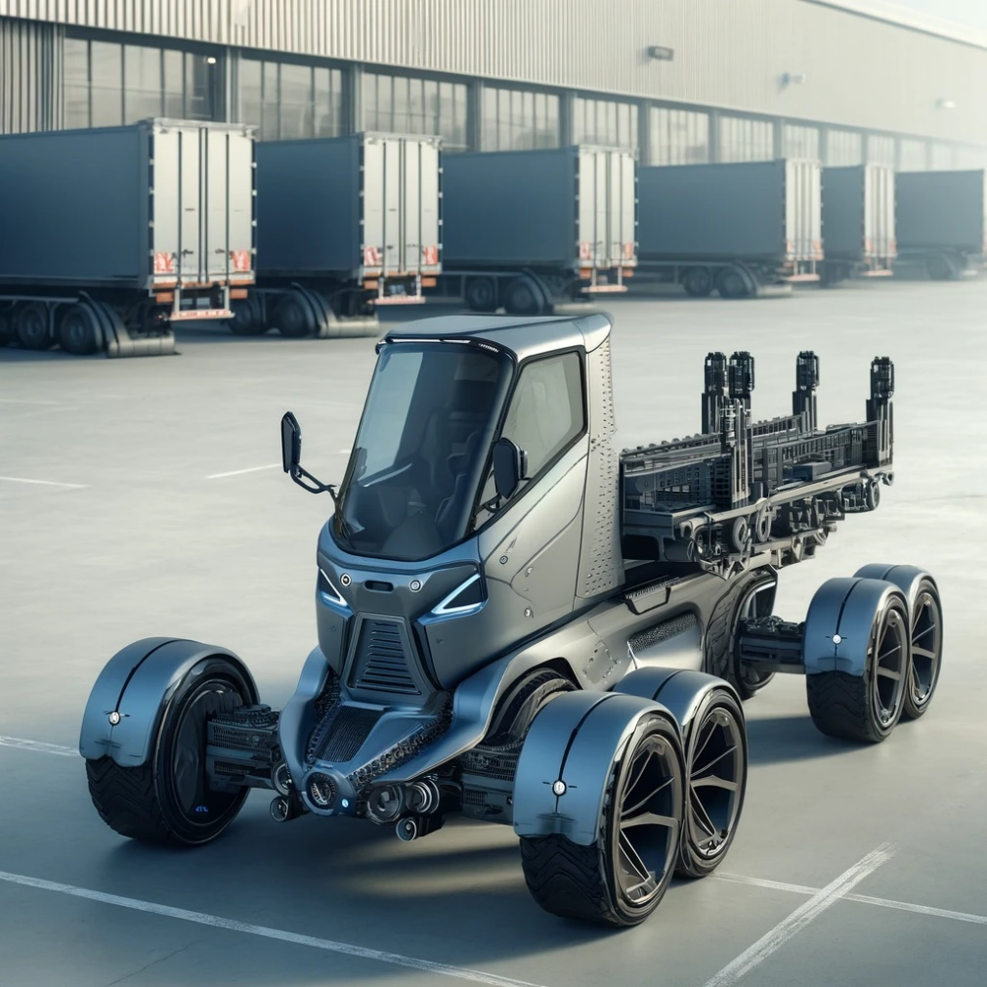

codeStart
| v
[Login Page] ---> [Role Selection: Admin/Driver]
| v
[Dashboard] | v
+-------------------------------+
| Modules |
|-------------------------------|
| 1. Vehicle Tracking |
| -> GPS for real-time |
| location updates |
| 2. Load Management |
| -> Input vehicle capacity |
| -> Monitor trailer loads |
| 3. Energy Monitoring |
| -> Track battery status |
| -> Charging alerts |
| 4. Maintenance Scheduling |
| -> Schedule servicing |
| -> Maintenance reminders |
| 5. Fleet Analytics |
| -> Usage reports |
| -> Performance insights |
| 6. Alerts & Notifications |
| -> Real-time updates |
+-------------------------------+
|
v
[User Action/Selection]
|
v
[Process Data and Display Results]
|
v
[End]
- Vehicle Tracking Module
- Core Features:
  - Real-time GPS location tracking of each trike in the fleet.
  - Route optimization using integrated maps.
  - Geo-fencing to alert if a vehicle goes off-course.
  - Historical route logs for analysis.
- Advanced Features:
  - Collision detection and alerts.
  - Integration with traffic data for dynamic route adjustments.

2. Load Management Module
- Core Features:
  - Input maximum load capacity for each trike and its trailers.
  - Monitor real-time load weights using integrated sensors.
  - Smart load distribution across multiple trailers.
  - Alerts for overload or uneven load distribution.
- Advanced Features:
  - Predictive load balancing for maximizing efficiency.
  - Integration with warehouse systems for automated load planning.

3. Energy Monitoring Module
- Core Features:
  - Real-time battery status tracking.
  - Charging station locator with route suggestions.
  - Energy consumption analysis to identify inefficiencies.
  - Alerts for low battery and estimated range left.
- Advanced Features:
  - Smart charging schedules based on vehicle usage patterns.
  - Integration with renewable energy sources (e.g., solar charging).

4. Maintenance Scheduling Module
- Core Features:
  - Automated reminders for periodic maintenance tasks (e.g., battery check, tire replacement).
  - Log of past repairs and costs for each vehicle.
  - Real-time fault detection from IoT sensors (e.g., motor issues, brake wear).
- Advanced Features:
  - Predictive maintenance using AI to foresee potential failures.
  - Integration with vendor services for part replacements.

5. Fleet Analytics Module
- Core Features:
  - Generate usage reports for each vehicle and driver.
  - Track fleet performance metrics like distance covered, fuel savings, or energy usage.
  - Cost analysis for operations, maintenance, and energy.
- Advanced Features:
  - Visual dashboards with KPIs for quick decision-making.
  - AI-driven insights to optimize fleet performance over time.

6. Alerts and Notifications Module
- Core Features:
  - Instant notifications for critical events (e.g., low battery, maintenance issues, route deviation).
  - Alerts for scheduled servicing or overloading.
  - Driver and admin-specific notifications.
- Advanced Features:
  - Customizable alert preferences (e.g., email, SMS, app push).
  - Smart alerts prioritizing critical over non-urgent issues.

7. Driver Management Module
- Core Features:
  - Driver profiles with work history and performance tracking.
  - Task assignments with delivery or route details.
  - Real-time communication between drivers and admin.
- Advanced Features:
  - Driver behavior analytics (e.g., speed, braking habits).
  - Gamification to encourage safer driving and better performance.

8. User Access and Role Management Module
- Core Features:
  - Role-based access control (Admin, Driver, Manager).
  - Define permissions for data visibility and actions.
- Advanced Features:
  - Multi-factor authentication for enhanced security.
  - Logs of user activity for auditing purposes.

9. Inventory Management Module (Optional)
- Core Features:
  - Track inventory items being transported.
  - Alerts for damaged or lost items.
- Advanced Features:
  - Integration with warehouse inventory systems for real-time sync.

10. Emergency Response Module
- Core Features:
  - SOS button for drivers to report emergencies.
  - Real-time location sharing with emergency contacts.
- Advanced Features:
  - Automatic alerts for crashes or vehicle malfunctions detected by sensors.
  - Emergency assistance dispatch integration

- General Specifications
- Type: Futuristic industrial electric trike with trailer compatibility.
- Load Capacity:
  - Trike: 200 kg.
  - Trailers (up to 5-6 trailers): Additional 300 kg.
  - Total Capacity: 500 kg.
- Dimensions:
  - Trike: 2.5m (length) x 1.2m (width) x 1.5m (height).
  - Trailer: 1.5m (length) x 1m (width) x 0.8m (height).

2. Powertrain and Battery
- Motor:
  - 5 kW (6.7 HP) brushless electric motor.
  - Torque: 120 Nm (sufficient for industrial loads).
- Battery:
  - 72V, 50 Ah lithium-ion battery.
  - Battery life: Up to 8 hours under full load.
  - Range: 80-100 km per charge (with regenerative braking).
- Charging:
  - Fast charging: 2-3 hours (DC).
  - Standard charging: 6-8 hours (AC).

3. Chassis and Suspension
- Frame:
  - Heavy-duty steel chassis with corrosion resistance.
  - Lightweight aluminum alloy trailers for load optimization.
- Suspension:
  - Front: Telescopic fork suspension.
  - Rear: Dual shock absorbers with load adjustment capabilities.
- Brakes:
  - Front: Hydraulic disc brakes.
  - Rear: Regenerative braking + disc brakes.

4. Tires and Wheels
- Tires:
  - Heavy-duty, puncture-resistant industrial tires.
  - Trike: 16-inch tires.
  - Trailers: 14-inch tires.
- Traction: All-terrain tread for indoor and outdoor industrial use.

5. Connectivity and Dashboard
- Dashboard:
  - Digital touchscreens display with real-time vehicle stats (speed, battery, load status).
  - Integrated GPS and navigation system.
- Connectivity:
  - Bluetooth and Wi-Fi for app integration.
  - IoT-enabled for remote monitoring via a fleet management app.
- Smart Features:
  - Geofencing alerts.
  - Maintenance reminders.
  - Driver authentication using RFID or biometric scanners.

6. Safety Features
- Lights:
  - LED headlight, taillight, and indicators for visibility.
- Stability Control: Anti-roll and load-balancing mechanisms.
- Emergency Features:
  - Panic button for drivers.
  - Automatic alerts for battery overheating or load mismanagement.
- Cameras and Sensors:
  - Rearview camera for reversing.
  - Proximity sensors for collision avoidance.

7. Trailer System
- Attachment System:
  - Quick-connect modular system for attaching trailers.
  - Automatic locking mechanism for stability.
- Load Distribution: Sensors for equal load balancing across trailers.
- Payload Surface: Flatbed with adjustable panels for various cargo types.

8. Environmental Adaptability
- Weatherproofing: IP65-rated chassis and electrical components for rain and dust resistance.
- Operating Temperature: -10°C to 50°C.
- Noise Level: <40 dB for quiet operation in sensitive industrial areas.

9. Optional Add-ons
- Solar panel integration for auxiliary charging.
- Swappable battery system for uninterrupted operation.
- Autonomous driving module for pre-mapped industrial routes.

Sales
The target audience for the Trike Cargo Trailer Electric includes:
- Urban Commuters: Individuals who need a practical and eco-friendly solution for transporting goods and supplies within urban environments.
- Small Businesses: Companies involved in local delivery services, food and beverage distribution, or retail operations that require a reliable and cost-effective cargo transportation option.
- Outdoor Enthusiasts: Adventure seekers and outdoor enthusiasts who need a versatile trailer for carrying camping gear, sports equipment, or recreational items.
- Eco-Conscious Consumers: Individuals who prioritize environmentally friendly transportation options and seek an electric-powered solution for their cargo hauling needs.
- Local Service Providers: Professionals such as landscapers, gardeners, or maintenance workers who require a convenient and efficient means of transporting tools and equipment for their daily work.
Feedback
User Experience
Warranty / maintenance services
Parts replacement
Upgrades customized.
Customer support channel
On the go help

